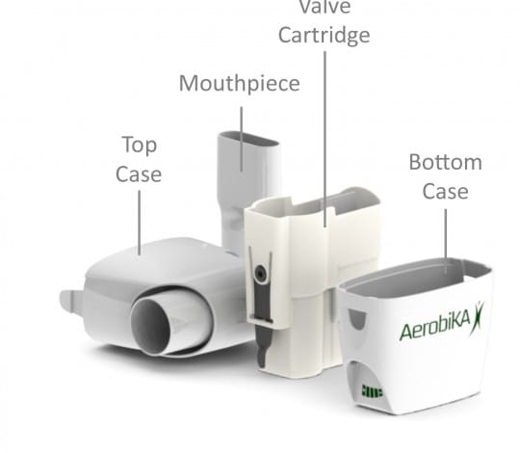
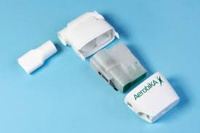
Aerobika® Cleaning Instructions
- Place Cartridge inside bottom case and attach top case, making sure it clicks and fits correctly.
- Place mouthpiece to top case.
- During next use ensure Aerobika oscillates and works correctly for treatment.

- After use, press tabs to separate top case from the bottom case

- Remove cartridge and mouthpiece.

- Place all parts into hot soapy water and soak for 15 minutes (or place in dishwasher)

- Shake off water and leave to dry.

Aerobika® Assembling

