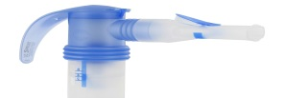

1. Remove the PARI PEP™ S System from the nebuliser (if applicable) and disassemble.
See PARI Nebuliser Instructions to clean and disinfect the nebuliser.

2. Wash all parts, except optional nose clip and tubing (not included), with warm water and a little dishwashing liquid. Rinse thoroughly with warm water and shake out water.

3. Air dry or hand dry PARI PEP™ S components on a clean, lint-free cloth. Reassemble PARI PEP™ S System when dry and store.

4. After cleaning and disinfecting, make sure the PARI PEP™ S has not lost its shape, been deformed or broken in any way. Reassemble PARI PEP™ S and ensure that all components have a snug, not difficult, fit. You may see some cloudiness of the material after boiling.

NOTE: For patients with Cystic Fibrosis, the CF Foundation recommends boiling in water for a full 5
minutes to disinfect.

Cleaning the PARI PEP™ S System

