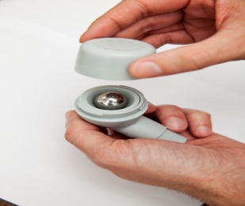
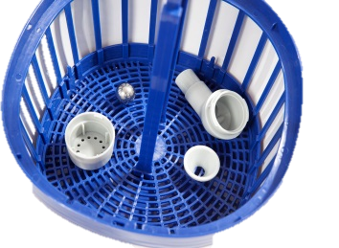
- Preparation
- Disassemble the Pari-O-Pep
- Set the ball to one side so that it cannot roll away
- Remove the lanyard from the lower part
- Cleaning
- Clean with dishwashing liquid in warm tap water
- Rinse the individual components thoroughly in running water

3) Disinfection
- Boil in a sufficient quantity of water (5 minutes) or steam disinfector for (6 minutes)
4) Drying
- Lay all parts on a clean, dry and absorbent surface
5) Storage
- After drying, always store the parts in the bag provided for the purpose

Pari-O-Pep™ Cleaning
Clean and disinfect immediately after use.

