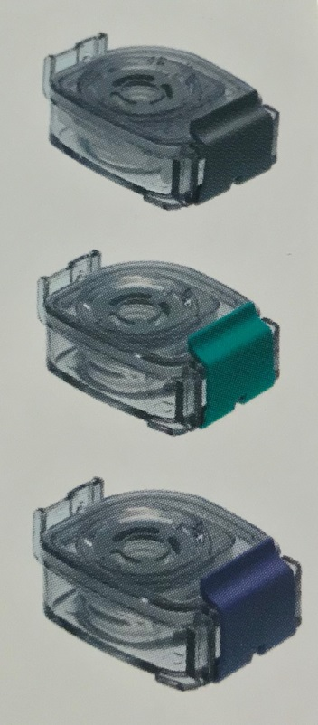

- Grey for Promixin (reconstituted with 1ml of diluent)
Colistin, Salbutamol

- Green for DNase

- Lilac for Tobramycin(x2 fills)
Hypertonic saline (x2 fills)
I-Neb® Chambers used in CF

For further information contact the I-neb product support team on:

0800 130 0857
I-Neb® Chambers used in CF

