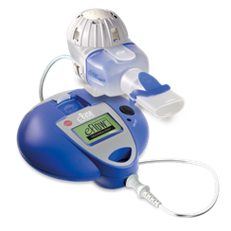
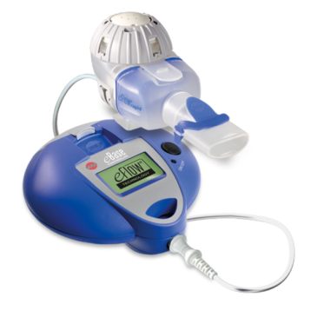
At the end of the day, disinfect the dismantled nebuliser handset (including the aerosol head) immediately after cleaning for about 15 minutes
Disinfection methods:
- Boil
- Steam steriliser
Drying
Place all components on a dry absorbent surface and air dry for 4 hours
Storing
Keep in a dust free place protected from contamination
Replacement parts
Aerosol heads are recommended to be replaced every
3 - 6 months and handsets every 12 months on average

- Take the nebuliser apart completely. Wash immediately with warm tap water and washing up liquid for 5 minutes

- After washing the aerosol head, rinse the front and back of the aerosol head for approx. 1 minute under warm running tap water.

- Clean the control unit and cord with a damp cloth

E-Flow® Cleaning Instructions
E-Flow® Disinfection

