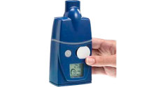
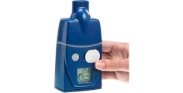
After each use:

- Place the mouthpiece, medication chamber, chamber lid and drug guide into the right places in the washing basket.
- Place the basket in warm soapy water (use 1 or 2 drops of liquid detergent).
- Move the basket back and forth in the water.
- Rinse the washing basket containing the parts in soft, distilled or filtered water. (If you have hard water, rinse with water that has been boiled and allowed to cool).
- Shake off excess water and leave parts to air dry.

Periodic maintenance:

- Whenever the body of the I-neb has liquid spilled on it, wipe with a clean damp cloth.
- There is a small valve in the mouthpiece. Make sure this is not twisted in any way. If the valve is twisted, run the valve under running water.

Weekly wash:

- Place the mouthpiece, medication chamber, chamber lid and drug guide into the right places in the washing basket.
- Put the basket into a pan of soft, distilled or filtered water with a couple of drops of liquid detergent.
- Bring the water to a boil.
- Boil for 6-10 minutes.
- Rinse with soft, distilled or filtered water.
- Shake off excess water and leave parts to air dry.

Every 6 Months:

- Throw away the mouthpiece, drug guide and the medication assembly. Replace with new parts.

Cleaning the I-Neb®

Cleaning the I-Neb®

