Dear Patient
Included in this package is your new handheld Spirobank Smart Spirometer, which helps you keep track of your lung function without coming to the hospital to record it. The Spirobank connects to your smart phone via Bluetooth and is quick and easy when completing a lung function test, which can then be sent to rde-tr.exetercf@nhs.net.
An instruction booklet is included with the device which we recommend you follow, however we have included some instructions regarding sending results and cleaning.

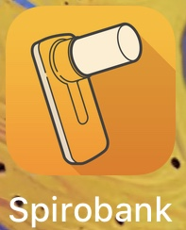
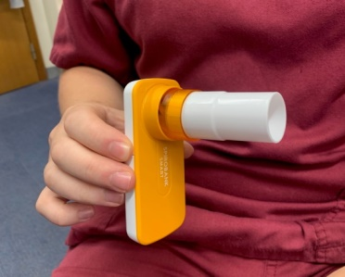
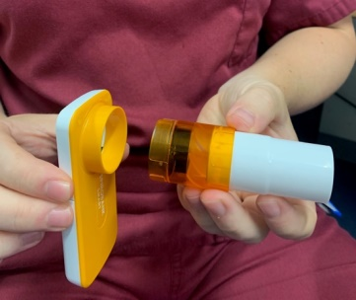
- Opening and assembling the device. Insert batteries and connect mouthpiece to the device by pushing the mouthpiece into the slot and locking it into position by twisting clockwise.

- Downloading the app and pairing the device. Download the MIR Spirobank app on the app store of your apple or android device. Follow the instructions when opening the app to create a new user profile, once this is complete it will connect the spirometer to your phone (make sure your Bluetooth is switched on! if it still does not connect make sure you enabled Bluetooth on the Spirobank app by looking in the app settings on your phone.)

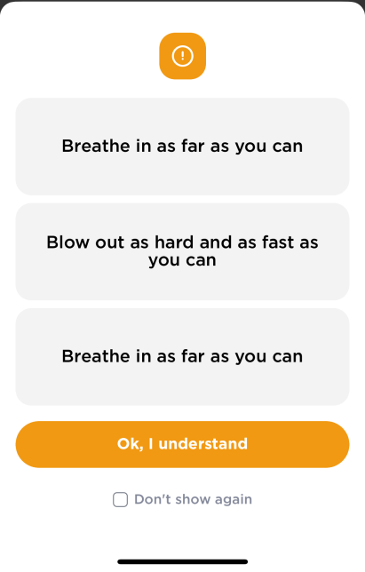
- Click start test and blow when instructed (remember to stand or sit upright, ensuring you get the best results possible!)
IMPORTANT NOTE:
AS NORMAL, TAKE A DEEP BREATH IN AND BLOW ALL THE WAY OUT, HOWEVER AFTER YOU HAVE BREATHED ALL THE WAY OUT, TAKE A DEEP BREATH IN AGAIN! (if you can’t inhale again after breathing all the way out don’t worry, it will still record your lung function

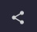
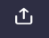
- Once you have completed your lung function test (aim to complete 3 blows) you will need to send your results to the team. Follow the instructions below when sending the results to rde-tr.exetercf@nhs.net. Click the top left logo at the top of the page to take you to the PDF results page then onto the email page (apple) (Android)
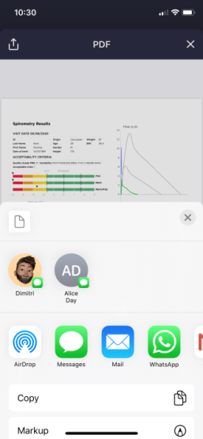
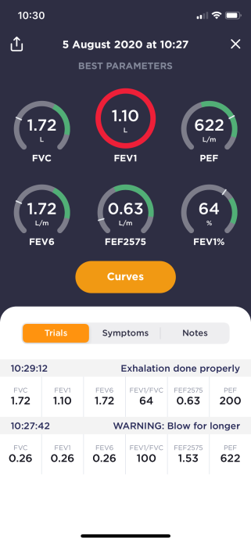
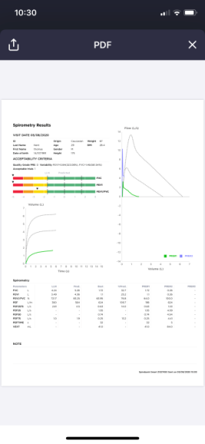

APPLE

ANDROID
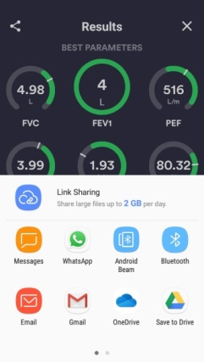
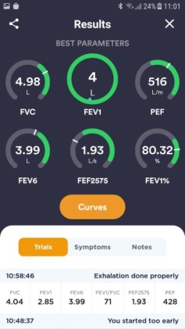

- Cleaning the reusable mouthpiece. Refer to the pages 13 & 14 for the correct cleaning instructions. Sterilising the mouthpiece and turbine are not recommended as the device is single patient use and can be damaged by sterilisation. It’s important to remember not to run the turbine under the tap as it can be easily damaged, just lightly agitate in a bowl of warm soapy water then place in another bowl of water to get wash off any excess soap.
Troubleshooting if spirobank fails to work.
1 – Check turbine is securely locked into device. (push turbine in securely and twist clockwise)
2 – Take cover off phone as this may interrupt connection.
3 – Delete and reinstall app on phone.
4 – Check Bluetooth is enabled on phone settings.
5 – Before commencing the test make sure you are holding the device stationary (hold it to the right or left of your mouth) and then CLICK START THE TEST
6 – Check the app is updated with the latest firmware.
7 – Contact Tom (Exercise Therapist) on 07929764681 for further support.

